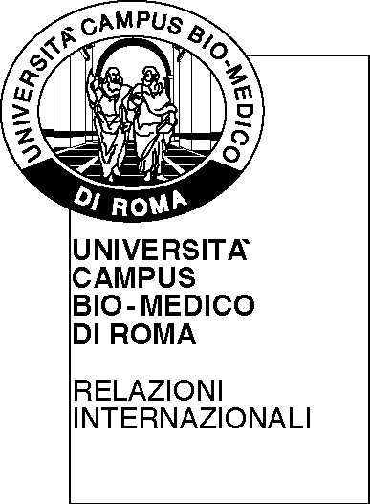 | UNIVERSITA’ CAMPUS BIO-MEDICO DI ROMA |   Funded by the Erasmus Plus Programme of the European Union
ERASMUS PLUS PROGRAMME KEY ACTION 1 – STAFF MOBILITY FOR TEACHING ASSIGNMENT. ANNO ACCADEMICO 2016/2017

TEACHING PROGRAMME

Sending Institution | UniversitÁ CAMPUS BIO-MEDICO DI ROMA  Via Álvaro del Portillo, 21  00128 – Roma
ID Erasmus Code | I ROMA14
International Relations contact person  (name, address, telephone and e-mail) | Dr. Daniela Astolfi  Via Alvaro del Portillo n.21 - 00128 Rome, Italy  tel. +39 06225418124  relazioni.internazionali@unicampus.it
Outgoing Professor | Nome del docente in uscita
AND
Receving Institution | Inserire nome università ospitante  inserire nome destinazione
ID Erasmus Code | inserire codice Erasmus destinazione
International Relations contact person  (name, address, telephone and e-mail) | Nome e dati della persona amministrativa di contatto
ACADEMIC contact person  (name, address, telephone and e-mail) | Inserire nome e dati del docente straniero

agree on the following teaching programme
Objectives of the mobility

Added value of the mobility (both for the host institution and for the teacher):

Mobility period* from to

Duration of teaching days :

Number of teaching hours (min. 8):

Teaching subject area (ISCED codes) :

Course/s of studies concerned:

Level of teaching: **

Number of students at the host institution benefitting from the teaching programme:

Language of teaching:

Content of the teaching programme (please define it carefully):

Expected results (not limited to the number of students concerned):

Is this the first time that you have applied for the Erasmus teaching staff mobility Programme?:

Date……………
Signature of the Professor

_______________________________

Authorisation from the Home Institution :  UNIVERSITÀ CAMPUS BIO-MEDICO DI ROMA  The Dean  Date:  Signature | Authorisation from the Host Institution :  Nome dell’Università ospitante  Cognome e nome del docente dell’Università ospitante:  Date:  Signature

NOTES:

* Mobility period: minimum 2 day (8 hours lesson), maximum 2 months.
** Level of teaching at the Host Institution: 1=Undergraduate (Laurea); 2=Postgraduate (Laurea Magistrale, Ciclo Unico); 3=Doctoral (Scuola di Specializzazione, Dottorato di Ricerca

