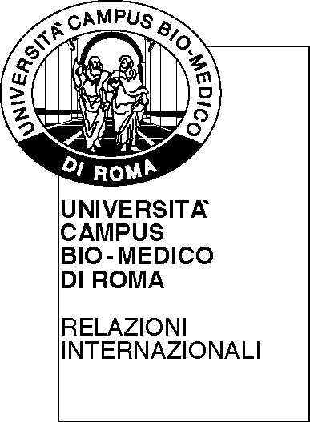 | UNIVERSITA’ CAMPUS BIO-MEDICO DI ROMA |   Funded by the Erasmus Plus  Programme of the European Union

ERASMUS PLUS PROGRAMME KEY ACTION 1 – MOBILITÁ INDIVIDUALE DEL PERSONALE PER FORMAZIONE ANNO ACCADEMICO 2016/2017

WORK PLAN

APPLICANT
Name and Surname

Telephone and e-mail | 0039 +
Age: Gender: □ Male □ Female
Title¹:
Home Institution:  Erasmus code: | Università Campus Bio-Medico di Roma, I ROMA 14  Via Álvaro del Portillo, 21  00128 - Roma

HOST INSTITUTION/ENTERPRISE
Name of the host institution or enterprise:
Erasmus code (if any):
Host Department:
Town/City: Country:
Sector/Economic fields²: Size of the enterprise³
Contact person (name, surname, telephone, e-mail):

Position:

MOBILITY PERIOD FROM: TO:  (between 2 days and 8 weeks) | NUMBER OF DAYS:
Overall aim and objectives of the mobility:

Type of activity to be carried out : □ Workshop □ Job shadowing □ Training □ Other_________

Activities to be carried out and if possible the programme for the period:

Language of the staff training period :

Expected results:

Authorisation from the Home Institution  Università Campus Bio-Medico di Roma  Responsabile dell’Area  Name :  Date:  Signature: | Applicant’s name  Signature:  Date: | Authorisation from the Host Institution/enterprise:  Name:  Position:  Date:  Signature:

NOTE PER LA COMPILAZIONE

^{1.} Title :
- Personale sanitario (Clinical staff)
- Personale tecnico (Technical staff)
- Personale amministrativo (Administrative staff)

^{2.} Sector/Economic fields

C | Manufacturing / Manufatturiero
D | Electricity, Gas, Steam and air conditioning supply / Erogazione elettrica, gas, vapore e aria condizionata
I | Accomodation and food service activities / Servizi alberghieri e ristorazione
J | Information and communication / Informazione e comunicazione
K | Financial and insurance activities / Attività finanziarie e assicurative
M | Professional, scientific and technical activities / Attività professionali, scientifiche e tecniche
N | Administrative and support service activities / Attività amministrative e di servizio
P | Education / Formazione
Q | Human health and social work activities / Servizi sanitari e sociali
R | Arts entertainment and recreation / Arti, intrattenimento e attività ricreative
S | Other service activities / Altri servizi

^{3.} Size of the enterprise:

- Small (1 - 50 staff)
- Medium (51 a 500 staff)
- Big (501 or more staff)

