Campus Bio-Medico University of Rome
International Relations Office
Via Álvaro del Portillo, 21
00128 – Roma

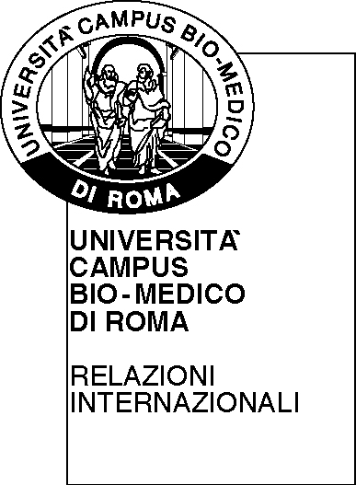
APPLICATION FORM

- Personal information
SURNAME
FIRST NAME
DATE OF BIRTH
E-MAIL ADDRESS
FACULTY | □ Medicine and Surgery  □ Engineering  □ Science and Technology for Human and the environment

- International mobility information:
TYPE OF MOBILITY ATTENDED | □ Erasmus+ Programme  □ Extra Erasmus
HOST INSTITUTION:
UCBM SUPERVISOR:
MOBILITY PERIOD - START/END DATES:
ECTS/CFU ACQUIRED*
* transcript of records required

- Short description of the activities carried out during the mobility and its impact on your academic experience:
____________________________________________________________________________________________________________________________________________________________________________________________________________________________________________________________________________________________________________________________________________________
The signed application form, together with the documents listed below, must to be sent to fondogiovani@unicampus.it no later than the deadline indicated in the Rector’s Decree:
- ID/Passport scanned copy;
- Transcript of records/work
- ISEE 2020 declaration

- Authorization
I authorize Campus Bio-Medico University of Rome to use the above information for University purposes: YES □ NO □

Date Applicant signature

______________________ ______________________

